**In21-S4-CS3063 – Theory of Computing**

**Assignment 02**

**NAME : K.S. RANASINGHE INDEX NO. : 210518H**

QUESTION 01

1. The grammar given here could be simplified into a single regular expression.

S → A10B

A → 0A | Λ 🡺 A → 0*

B → 1B | 0B | Λ 🡺 B → (0|1)*

Based on the above simplification of A and B, we could write a regular expression for S as follows;

**S → 0*10(0|1)\***

Using this expression, we could draw a state diagram for NFA representing the language.

0

**1**

1

0

**2**

**3**

0,1

1. L1 represents a language which is;

* Starting with a string of length greater than or equal to zero containing ‘0’s.
* Followed by the string ‘10’.
* Ending with a string of length greater than or equal to zero containing any combination of ‘0’s and ‘1’s.

1. CFG 🡺 CNF

**Step 01 – Eliminate Λ-productions**

S → A10B | A10 | 10B | 10

A → 0A | 0

B → 1B | 0B | 1 | 0

**Step 02 - Eliminate unit productions**The modified grammar doesn’t contain any unit productions. Therefore, we could skip this step.

**Step 03 - Restrict the RHS of productions to single terminals or strings of ≥ 2 non-terminals**

First we will remove the terminals by introducing two new states as follows;

X → 0

Y → 1

The new grammar as follows;

S → AXYB | AXY | XYB | XY

A → XA | 0

B → YB | XB | 1 | 0

X → 0

Y → 1

**Step 04 - Replace each production having > 2 non-terminals on RHS by an equivalent set of productions each having exactly 2 nonterminals on the RHS**

We will introduce two more states here;

P → AX

Q → YB

The final modified grammar is as follows;

**S → PQ | PY | XQ | XY**

**A → XA | 0**

**B → YB | XB | 1 | 0**

**P → AX**

**Q → YB**

**X → 0**

**Y → 1**

QUESTION 02

1. L = {anbbb2n | n ≥ 0}

a, Z0 / aZ0

b, b / Λ

**q0**

b, a / ba

b, Z0 / b

Λ, Z0 / Z0

**q1**

**q2**

a, a / aa

b, a / b

1. L = { Σ={a, b}, includes : “**aaba**aabbaaaa”, “**babba**aabbbbaabb”, “**bab**bbaabb” }

a, a / aa

b, b / bb

a, b / ab

b, a / ba

Λ, Z0 / Z0

Λ, a / a

Λ, b / b

a, Z0 / aZ0

b, Z0 / bZ0

Λ, Z0 / Z0

**q2**

**q1**

**q0**

**q1\***

a, a / Λ

b, b / Λ

a, a / a

b, b / b

b, a / b

a, a / aa

b, b / bb

a, b / ab

b, a / ba

QUESTION 03

i) This TM reverses the input string.

**Initial (S1)**

|  |  |  |  |  |  |  |  |  |  |  |  |  |  |  |  |  |  |  |  |  |  |
| --- | --- | --- | --- | --- | --- | --- | --- | --- | --- | --- | --- | --- | --- | --- | --- | --- | --- | --- | --- | --- | --- |
| Δ | **0** | **0** | **1** | **1** | **0** | **1** | **0** | **1** | **0** | **0** | Δ | Δ | Δ | Δ | Δ | Δ | Δ | Δ | Δ | Δ | Δ |

**Final (S2)**

|  |  |  |  |  |  |  |  |  |  |  |  |  |  |  |  |  |  |  |  |  |  |
| --- | --- | --- | --- | --- | --- | --- | --- | --- | --- | --- | --- | --- | --- | --- | --- | --- | --- | --- | --- | --- | --- |
| Δ | Δ | Δ | Δ | Δ | Δ | Δ | Δ | Δ | Δ | Δ | **0** | **0** | **1** | **0** | **1** | **0** | **1** | **1** | **0** | **0** | Δ |

**ii)**



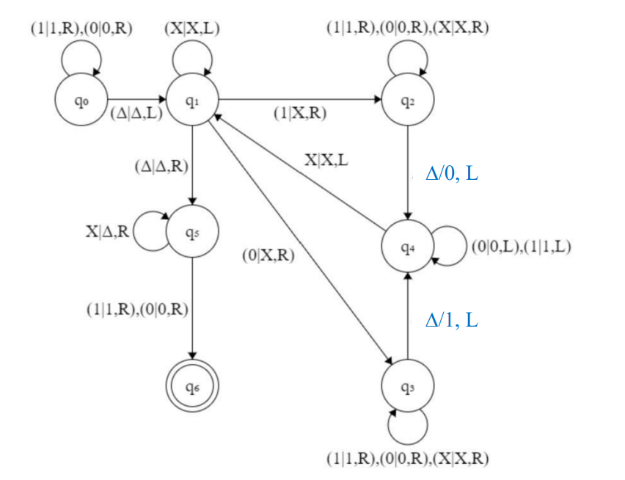

(Λ | 1 , L)

(Λ | 0 , L)



**Initial (S1)**

|  |  |  |  |  |  |  |  |  |  |  |  |  |  |  |  |  |  |  |  |  |  |
| --- | --- | --- | --- | --- | --- | --- | --- | --- | --- | --- | --- | --- | --- | --- | --- | --- | --- | --- | --- | --- | --- |
| Δ | **0** | **0** | **1** | **1** | **0** | **1** | **0** | **1** | **0** | **0** | Δ | Δ | Δ | Δ | Δ | Δ | Δ | Δ | Δ | Δ | Δ |

**Final (S3)**

|  |  |  |  |  |  |  |  |  |  |  |  |  |  |  |  |  |  |  |  |  |  |
| --- | --- | --- | --- | --- | --- | --- | --- | --- | --- | --- | --- | --- | --- | --- | --- | --- | --- | --- | --- | --- | --- |
| Δ | Δ | Δ | Δ | Δ | Δ | Δ | Δ | Δ | Δ | Δ | **1** | **1** | **0** | **1** | **0** | **1** | **0** | **0** | **1** | **1** | Δ |

(0|0,R)

(1|1,R)

(Δ|Δ,L)

(1|X,L)

(1|1,L)

(0|0,L)

(1|1,L)

(Y|Y,L)

(0|Y,R)

(X|X,L)

(0|0,R)

(1|1,R)

(0|0,L)

(1|1,L)

(Y|0,L)

(1|1,R)

(0|0,R)

(1|1,R)

(X|1,R)

(Δ|Δ,L)

q0

q1

q2

q3

q4

q5

q10

q7

q9

q8

), ( / Λ

**q0**

(, ( / ( (

(, Z0 / (

Λ, Z0 / Z0

**q1**

**q3**

QUESTION 04

(, ( / ( (

(, Z0 / ( Z0

(, ( / ( (

(, Λ / (

(Y | Y, R)

(X | X, R)

( ) | ) ,L)

(X | X,L)

( ( | ( ,R)

( ) | ) ,R)

(Δ|Δ,L)

q3

q2

q5

q4

q1

q0

(Δ|Δ,R)

(X | X, L)

(Y |Y, L)

( ) | Y,L)

( ( | X,R)

(Y | ) ,R)

(X | ( ,R)

(Δ|Δ,L)